**DSCI 723 data management & Warehousing**

**TERM PROJECT – CUSTOM CLOSET CONTRACTORS**

SHAREEF SHAIK

Submission Date April 27 2023

**Abstract:**

The main focus of this article is on developing an entity-relationship diagram and database design for Custom Closet Contractors (C3), a family-owned company looking to streamline its operations and boost profitability. The article opens with introducing Mitch Mackenzie, the main character of the book, who is employed by C3 to assess their activities. Mackenzie learns that the majority of the customer data at C3 is kept on paper, which leads to miscommunications between the production crew and the front office. Mackenzie creates a new database schema with seven entities, including Company, Customer, Consultation, Designer, Installation, Installer, and Unit, to overcome this issue. The page offers a thorough discussion of the cardinality between entities as well as the characteristics, connections, and functional dependencies of each entity.

The essay also discusses potential ethical and privacy problems associated with data collection and database storage. In-depth discussions are held regarding data security, misuse, accuracy, discrimination, transparency, and retention. The company is required to respect the privacy rights of its customers, ensure the data's accuracy, prohibit discrimination, and be transparent about data collection and storage. The need of carefully weigh ethical and privacy issues before collecting and storing data in a database is emphasized in the article's conclusion.

Overall, this article addresses important ethical and privacy problems that organizations must consider when handling consumer data and offers a thorough description of the design of an entity-relationship diagram and database schema for C3. Businesses can utilize the information provided to create efficient database schemas that respect consumer privacy rights while assuring the accuracy and security of the data.

**Table of Contents**

**Business Problem Description3**

ERD Diagram3

Entities4

**Cardinalities & Relationships6**

Relationship Schema7

Functional Dependencies7

Database Diagram9

Data Warehouse Diagram10

Data Dictionary10

Privacy Issues & Potential Ethics11

Table of figures:

Figure 1 Entity Relationship Diagram 3

Figure 2 Relational Schema 7

Figure 3 Relational Database Diagram 9

Figure 4 Data Warehouse Database Diagram 10

Figure 5 Data Dictionary 10

**Business problem description:**

The protagonist of the novel is Mitch Mackenzie, a recent graduate of a business school who is engaged by his family's company, Custom Closet Contractors (C3), to evaluate their processes and boost profitability. Mackenzie learns that most of the customer data at C3 is kept on paper, which causes misunderstandings between the front office and the production team. He understands that he will have to design all the crucial business procedures from scratch. The story also gives background information on C3's history and activities, the Canadian home organization market, and the difficulties they have in a highly fragmented market.

**ERD Diagram:**

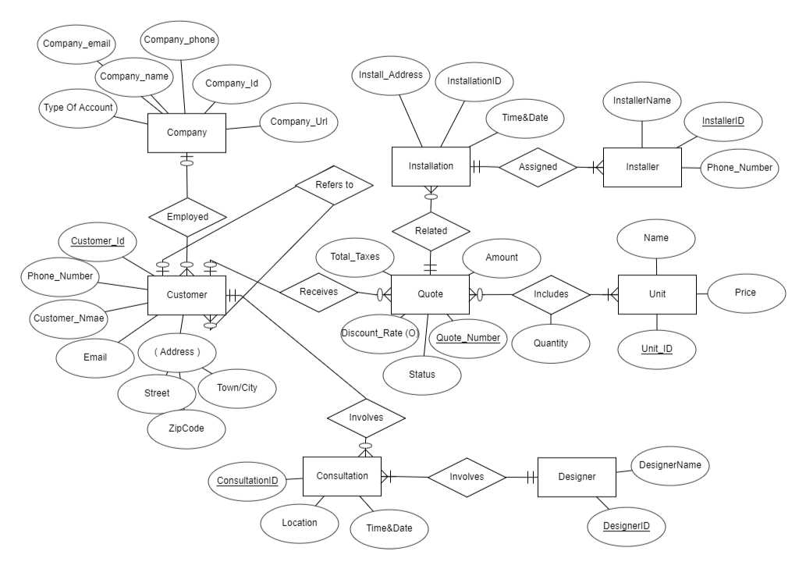

**Entities:**

* Customer
* Company
* Consultation
* Designer
* Installation
* Installer
* Unit

The diagram includes the following entities and relationships:

Attributes for each entity based on the business problem:

**Customer:**

Customer ID (unique identifier)

name

Address

Phone number

Email

**Company:**

Company ID (unique identifier)

Name

Address

Phone number

Email

**Consultation:**

Consultation ID (unique identifier)

Date/time

Location

**Designer:**

Designer ID (unique identifier)

name

**Installation:**

Installation ID (unique identifier)

Unit ID (foreign key)

Installer ID (foreign key)

Date/time

**Installer:**

Installer ID (unique identifier)

name

Phone number

**Unit:**

Unit ID (unique identifier)

Name

Price

**Cardinality and Relationships:**

Company and Customer have a one-to-many (1:N) relationship, as a company can have multiple customers, but a customer belongs to only one company.

Customer and Consultation have a one-to-many (1:N) relationship, as a customer can have multiple consultations, but a consultation belongs to only one customer.

Designer and Unit have a one-to-many (1:N) relationship, as a designer can design multiple units, but a unit is designed by only one designer.

Unit and Installation have a one-to-many (1:N) relationship, as a unit can be installed multiple times, but each installation is associated with only one unit.

Installer and Installation have a many-to-one (N:1) relationship, as an installer can perform multiple installations, but each installation is performed by only one installer.

**Relational Schema:**

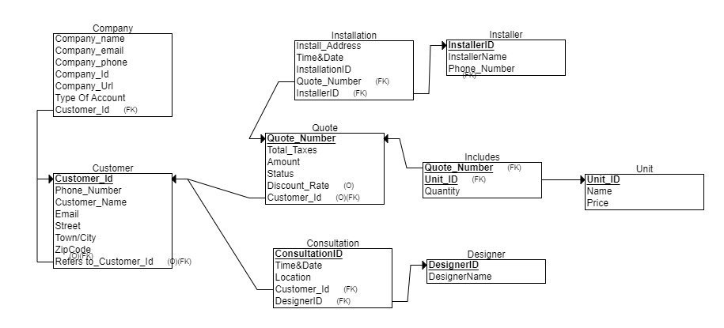

**Functional Dependencies:**

Company -> {Company_name, Company_email, Company_phone, Company_ld, Company_Url}

The company information determines the company name, email, phone number, location data, and website URL.

Customer -> {Customer_id, Customer_name, Phone_number, Email, Address}

The customer information determines the customer ID, name, phone number, email, and address.

Installation -> {Install_Address, Time&Date, InstallationID, Quote_Number (FK), InstalleriD (FK)}

The installation information determines the installation address, date and time, ID, quote number, and installer ID.

Quote -> {Quote_Number, Total_Taxes, Amount, Status, Discount_Rate, Customer_Id (FK), Foreign_Key}

The quote information determines the quote number, total taxes, amount, status, discount rate, customer ID, and foreign key.

Consultation -> {ConsultationID, Time&Date, Location, Customer_Id, DesigneriD (FK), InstalleriD (FK)}

The consultation information determines the consultation ID, date and time, location, customer ID, designer ID, and installer ID.

Installer -> {InstallerID, InstallerName, Phone_Number}

The installer information determines the installer ID, name, and phone number.

Unit -> {Unit_ID, Name, Price}

The unit information determines the unit ID, name, and price.

**Database Diagram:**

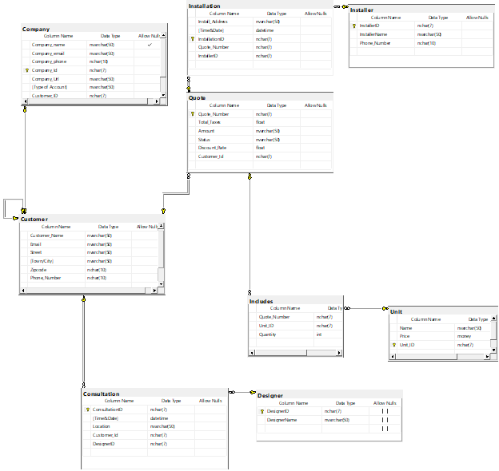

**Data Warehouse Diagram:**

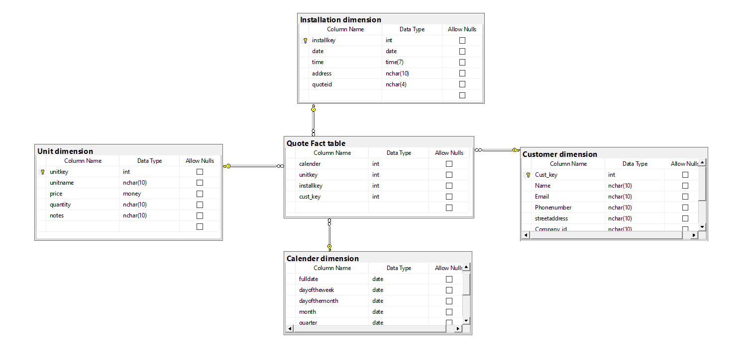

**Data Dictionary:**

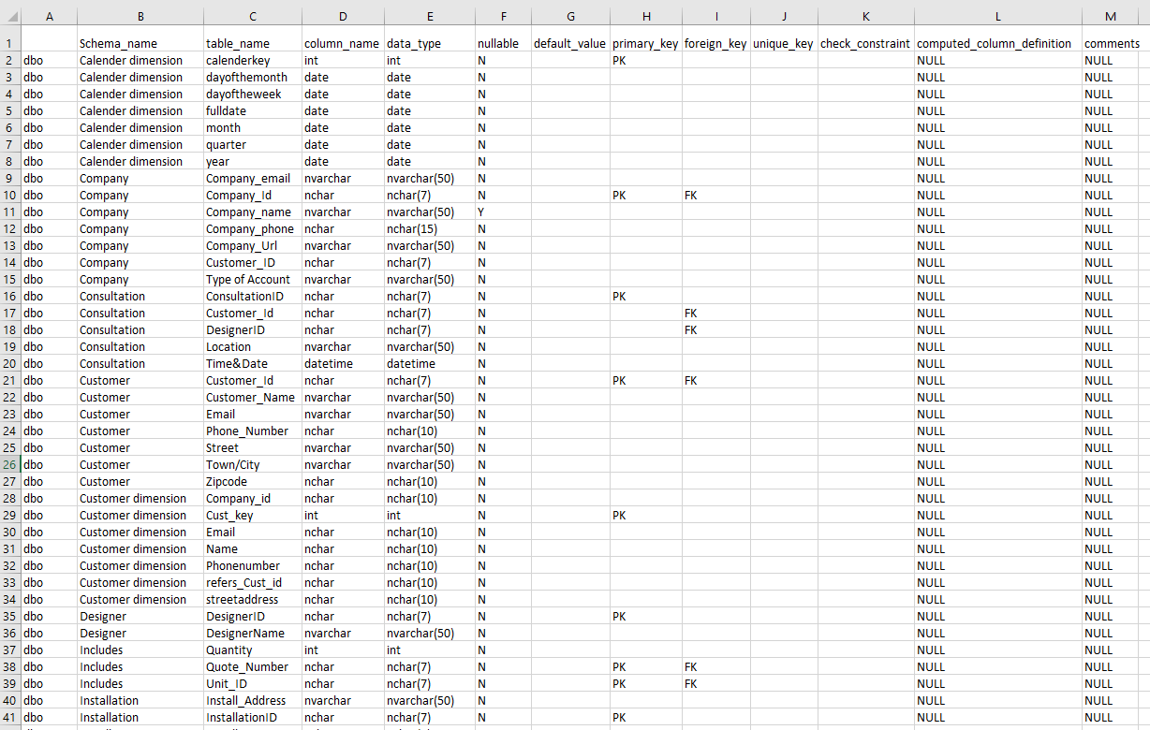

**Privacy issues and potential ethics:**

In order to make sure that the information is handled properly, it is crucial to take these concerns into account when collecting and storing data in a database. The following are some possible ethical and privacy problems that could arise from gathering data for the database that was planned:

**Data Security:** To prevent unauthorized access, hacking, or theft of sensitive data, the database must have the necessary security measures in place. Identity theft, fraud, and other unlawful acts could result from a data security breach that compromises client information, including names, addresses, and payment information.

**Data Misuse:** The information must only be utilized for proper company purposes and not for private gain. The improper use of data may result in a privacy violation, harm to one's reputation, or legal action.

**Data Accuracy:** The information kept in the database needs to be accurate, complete, and current. Inaccurate data may result in bad business decisions, unhappy customers, and legal problems.

**Discrimination:** The information cannot be utilized to unfairly treat clients or staff members based on their race, gender, ethnicity, religion, or other personal traits. Legal action and reputational harm to the business could result from discrimination.

**Transparency:** The business needs to be open and honest about the information it gathers, how it uses it, and who has access to it. Customers must be made aware of their rights under data protection laws, including the ability to access and update their personal data.

**Data Retention:** The corporation is only required to retain customer information for as long as is required to fulfil business obligations. Data retention that is excessively long-term may result in privacy violations, harm to one's reputation, or legal action.

In conclusion, thorough consideration of ethical and privacy considerations is necessary before gathering and storing data in a database. The business must respect the privacy rights of its consumers, have adequate security measures in place, guarantee the accuracy of the data, avoid discrimination, and be upfront about data collection and retention.